Ценоразпис
на външни генераторни захранвания за фотографски светкавици

ELEKTRONA, | СЛОВЕНИЯ | цена лева с ДДС/ Euro incl. VAT
FLASH FEEDER COMPACT 230V/50Hz | 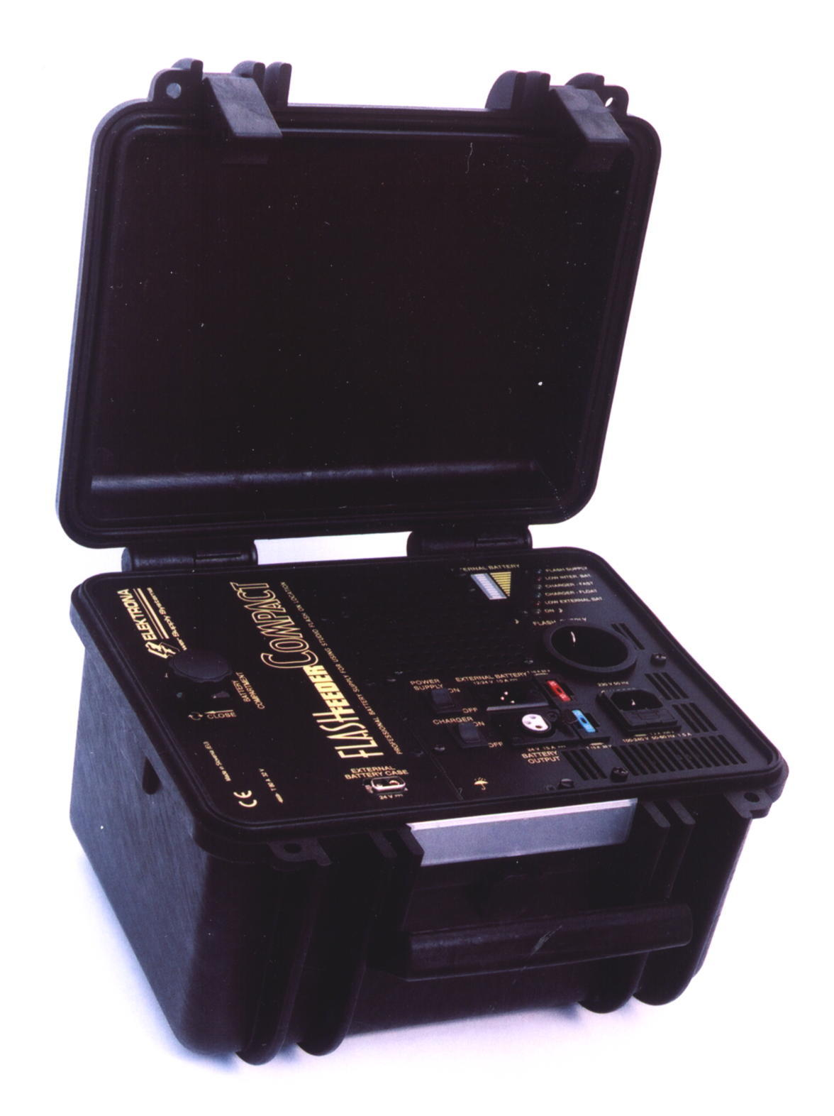 | 3317 / 1695
COMPACT BATERRY CASE  With 2x mono power connector | 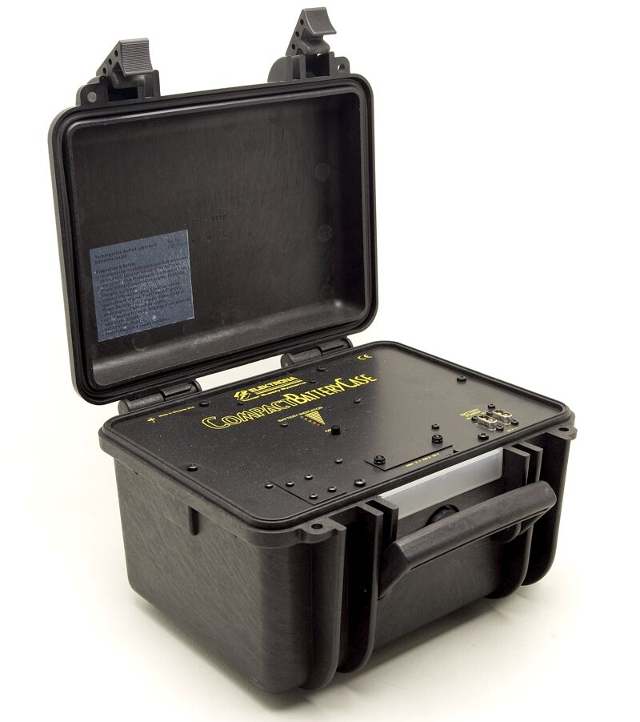 | 1497 / 765
DC POWER CORD WITH CIGARETTE LIGHTER CONNECTOR, 2M | 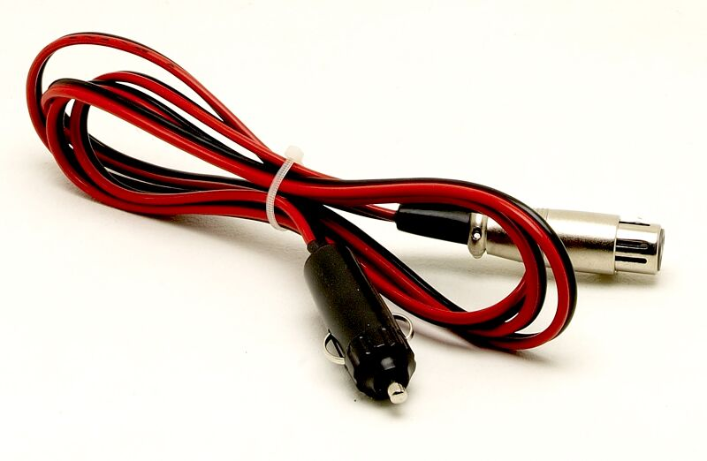 | 88/ 45
DC POWER CORD WITH CONNECTION CLAMPS FOR EXTERNAL BATTERY CONNECTION, 2M | 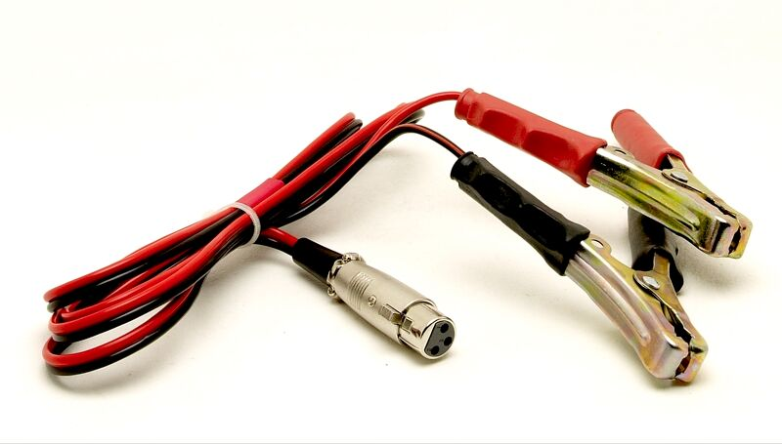 | 88 / 45
AC (230V, SHUKO) POWER CORD WITHGROUND, 2M |  | 37 / 19
DC POWER CORD WITH MONO POWER CONNECTORS CONNECTING EXTERNAL BATTERY CASE TO FLASH FEEDER COMPACT | 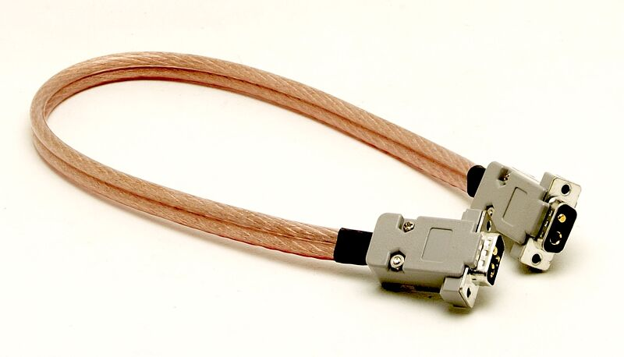 | 221 / 113
BATTERY PACK FOR FLASH FEEDER COMPACT | 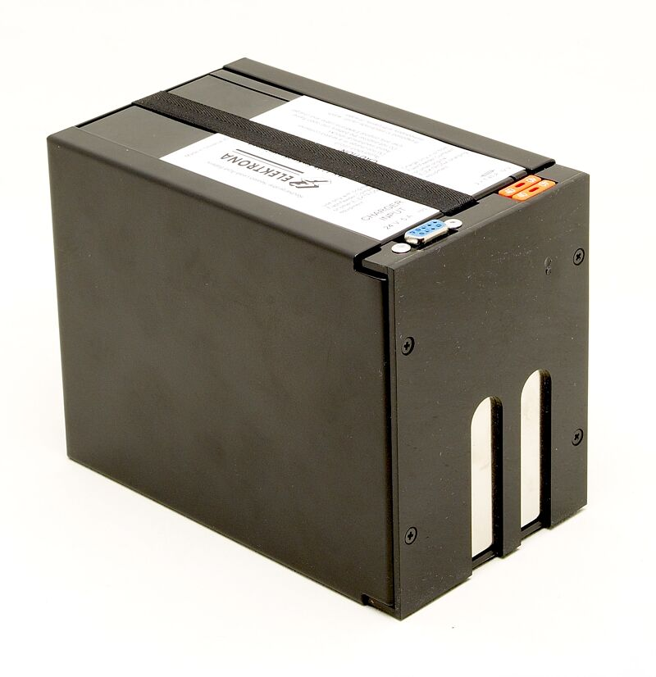 | 505 / 258
 |  | 76 / 39
  DC POWER CORD FOR EXTERNAL CHARGING OF ONE BATTERY PACK, 0,6M
DC POWER CORD FOR EXTERNAL CHARGING OF TWO BATTERY PACK, 0,9M | 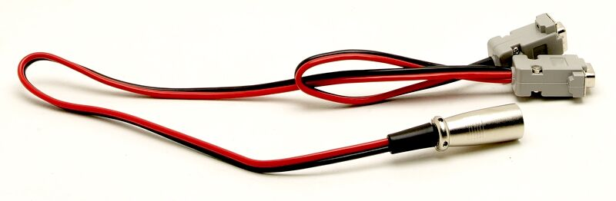 | 111 / 57
DC POWER CORD FOR EXTERNAL CHARGING OF THREE BATTERY PACK, 1,2M |  | 135 / 69
 | ФИЛИПИНИ
  INNOVATRONIX,
EXPLORER 1200Ws – 230V/50Hz | 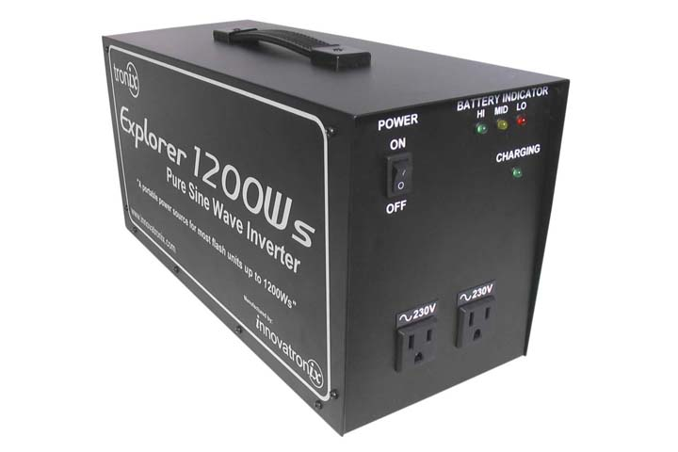 | 560 / 286
Цените са крайни за клиента и включват ДДС.
Цените могат да бъдат променяни без предупреждение.
Цените са валидни от 10.04.2008

