EXPLORER 1200

Мобилно захранване за студийни светкавици от 12В акумулатор.
Exporer 1200 осигурява променливо напрежение за нормална работа на светкавиците Ви.
Поддържа импулсни мощности до 1200W/s.
Прецизна форма на изходното 230 V напрежение.
До 1000 импулса при 300W/s.
Направете своята заявка сега.
029801780
www.nfsbg.com

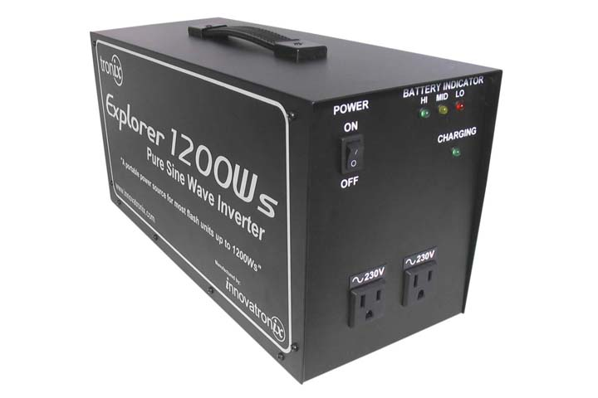

Характеристики

Цени за доставка на инвертора 12-230V EXPLORER 1200W/s

Цена с 10-12 дневна доставка – 699 лв.
Цена с 30-35 дневна доставка - 633 лв.

Цените включват ДДС и подлежат на промяна без предизвестие.

Explorer 1200 Таблица за съвместимост
Моля, проверете съвместимостта на Вашите светкавици с Explorer 1200
Strobe Compatibility:
Brand / Manufacturer-Distributor | Model No. | Compatibility
Alienbees / Paul C. Buff Inc. | B400 / B800 / B1600 | Yes
Aurora / Aurora Lite Bank | G-400 / G-800 | Yes
Balcar | Jazz 350, 750, 1500 | Yes
 | Balcar A2400, Starfish 1600ws | Yes
 | Classic 350, 750, 1500 | No
Bowens / Bowens International | Esprit 125/ 250/ 500/ 1000/ 1500 | Yes
 | Esprit2 500 / Prolight 120 | Yes
 | Esprit Digital DX250/ DX500/ DX1000 | No
 | Esprit Digital 750 Pro | No
 | Monolite 400e, Monolite 750 special | Yes
Britek | Pro-750/ Pro-500 | Yes
 | HS-2000/ HS-1000/ HS-600/ HS-500 | Yes
 | PS-200H/ PS-300H | Yes
Calumet | Travelite 750 | Yes
Comet | 1200w | Yes
Dyna-Lite / Dyna-Lite Inc. | 500wi/ 1000wi (power pack) | No
 | 1000ER/ 2000ER (power pack) | Yes
 | 800e | Yes
 | M1000e, M1000er | Yes
 | Uni250R, Uni400JR (monolight, AC models only) | Yes
 | **M1000DR, M1000WI, M1000, M1000x, M500 | No
Elinchrom / Elinca SA | Style 100FX / 400FX | No
 | Style 300RX / 600RX/ 1200RX | No
 | Style 300S / 600S / 1200S | Yes
 | Style 300 / 600 | Yes
 | Classic EL 500 / EL1000 | Yes
 | Micro 750 BI | Not tested
Falcon Eyes / Falcon Eyes Ltd. | Studio Flash System, 2-stop control panel | Yes
 | FE 500 | Yes
Interfit / Paterson Photographic Ltd. | 150i / 300i | Yes
 | 500s / 1000s | Yes
 | Combo 700 / Combo 1200 | No
Hensel | Integra 500 Monolight | Yes
JTL / JTL Corporation | Versalight 200/ 300/ 500/ 800 | Yes
 | Versalight D 300 / D500 / D 800 / D 1000 | No
 | Versalight J160/ J110 | Yes
 | Mobilight 200/ 300 | Yes
Lumedyne / Lumedyne Inc. | Next Generation Series (power packs and flash heads) | Yes
 | Signature Series (power packs and flash heads) | Yes
Norman / Photo Control Corp. | ML 600 / 600 R | No
 | 800 superlite | Yes
 | P800D/ 800 superlite | Yes
 | Allure DP320 / Allure C1000 | Yes
Novatron / Novatron | 2103-FC | Yes
 | 2140-C / 2120-C / 2110-C / 2105-C / 2100-C | Yes
Photogenic / Photogenic Machine Co. | Powerlight 1250 DR / 500 DR/ 100 DR | No
 | PL750/ PL1250 | Yes
 | Studiomax II AK320B / AK 320 | Yes
 | Studiomax II AK160B / AK 160 | Yes
Pro-foto / Profoto | Compact 300/ Compact Plus 600/ Compact Plus 1200 | Yes
 | Profoto 300/600 | Yes
 | Acute 600e | Yes
 | Acute2 | Yes
Pro Series | Pro Series | Yes
Smith-Victor (SV) | Flashlite 300ix / 200ix | Yes
SP (by BKA) | Excalibur SP 1600C Compact Monolight | Yes
 | Excalibur 3200 Monolight / 6400 Monolight | Yes
 | SP Studio Systems 1600 Monolight | Yes
Speedotron / Speedotron Corp. | Force series / Force 10*** (digital with analog power ratio controller) | No
 | Speedotron 1205, 2403cx | Yes
 | Brown line (power packs and flash heads) | Yes
 | Black line (power packs and flash heads) | Yes
Visatec / HasselbladUSA | Solo Series | Yes
Visio / Koyo Lighting | Visio 600 / 1000/ 1600/ 2400 | Yes
White Lightning / Paul C. Buff Inc. | X800 / X1600 / X3200 | Yes
 | Ultra 600/ Ultra 1800 | Yes
 | UZ800 / UZ1600 | Yes
 | WL10000, WL Ultra1200 | Yes
Helpful tip: If your brand or model is not listed, check its power ratio control. This control is usually located either at the back or side panel of your flash unit.
▪ To check if it is compatible:
If the power ratio control (power ratio variator) is a rotary or a slide switch, it is compatible with the Explorer. It is also compatible when the flash unit has no or basic (1/4, ½, 1) power ratio control.
▪ To check if it is not compatible:
If the output control (power ratio variator) is digital and has a digital read-out, the Explorer may or may not work with your flash.
**NOTE: There have been conflicting customer reports on these models, there have been customers who says it is compatible while there are also customers who say otherwise. In this regard, to ensure customer satisfaction, these models are not recommended for Explorer

